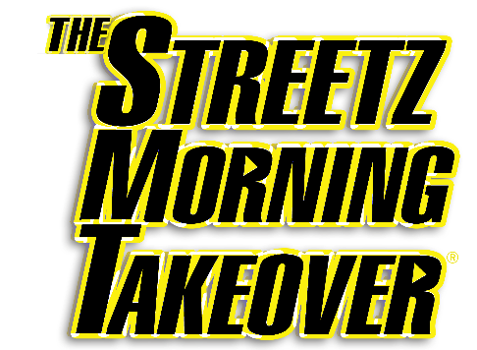

SHOW FEATURES

THE DATE DILEMMA
- The most popular feature on the show, the Date Dilemma features couples from a date that didn’t go well. With the help of the Streetz Morning Takeover, one person tries to get another chance or date.

LOVE DOC JOC
- Hosted by Yung Joc, listeners send in relationship issues through Instagram and with the help of Joc’s advice, figure out how to handle each situation.

THE JUICEBOX
- The Juicebox is the gossip segment on the show lead by Su Solo. Su delivers the top 3 most interesting and controversial gossip stories in the world of Hip Hop.

THE SMALL BUSINESS UPDATE
- The Small Business Update is designed to give small business owners a chance to highlight their business on the radio.

TRENDING TOPICS
- Trending topics focuses on the most trending conversations happening around the world on social media. The feature gives listeners a chance to interact directly with the personalities.

